Lab 19: Archimedes Principle

Group Submission
Yoaneli Ortiz, Trung Vo, Patrick Ignaut, Marjory Cevallos, Madelyn Woodrow

PHYS 1401
College Physics -1

4/14/2025

TABLE OF CONTENTS

Objective 3
Equipment 3
Theory and Equations 5
Procedure 6
Data and Observations 8
Calculations 9
Results 12
Sources of Error 13
Discussion 13
Conclusion 13

OBJECTIVE:
To measure the density of different materials by using Archimedes Principle. Either the Force Sensor, or the Triple Beam Balance will be used, but it is not necessary to use both.

EQUIPMENT:
Vernier Calipers | Large Rod x2 | Large Rod Base | Triple beam balance
Multi-clamp | String | Weight Set | Force Sensor
Container for water
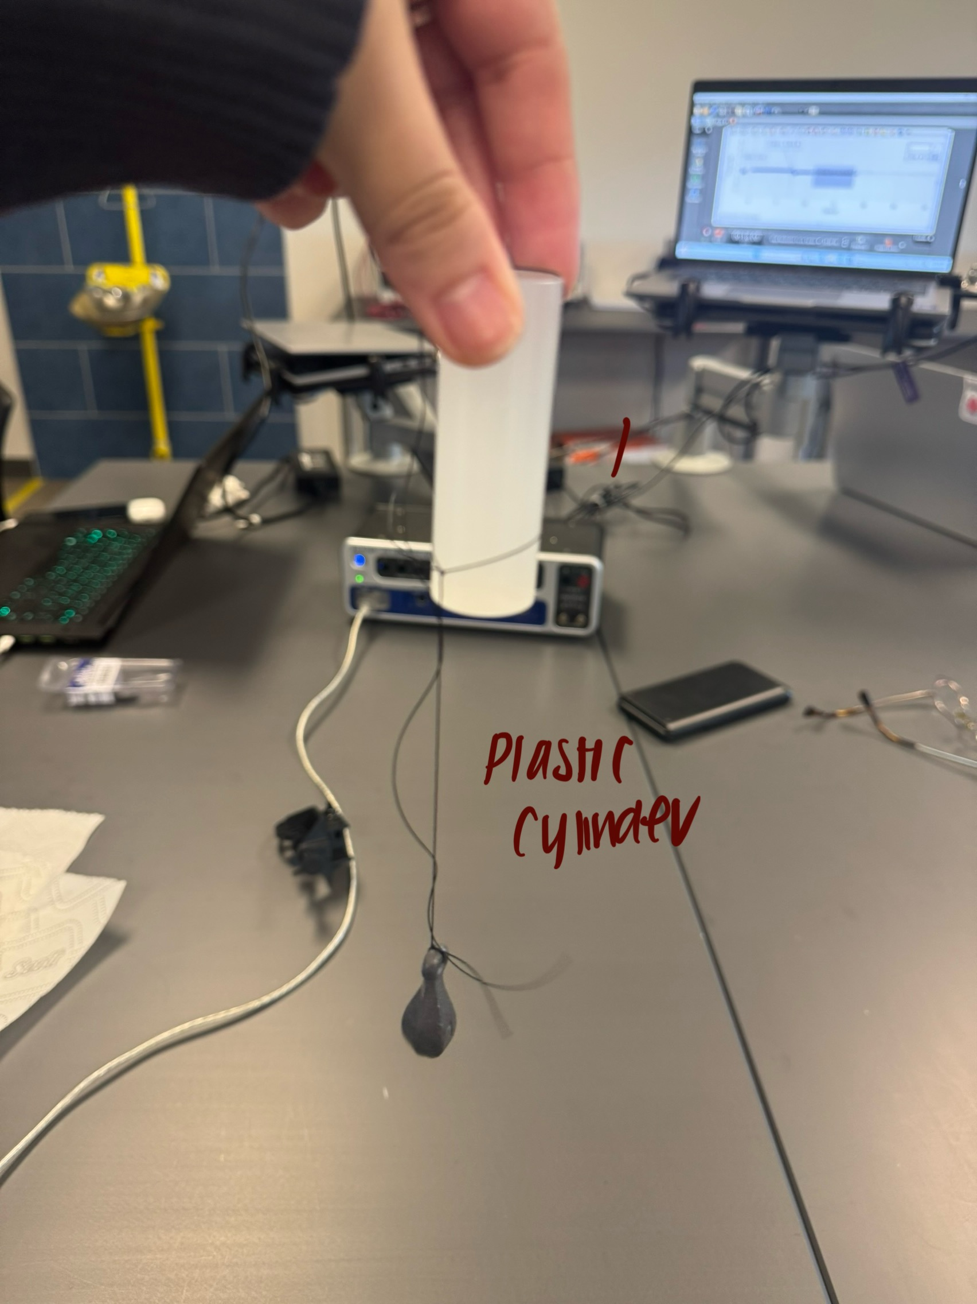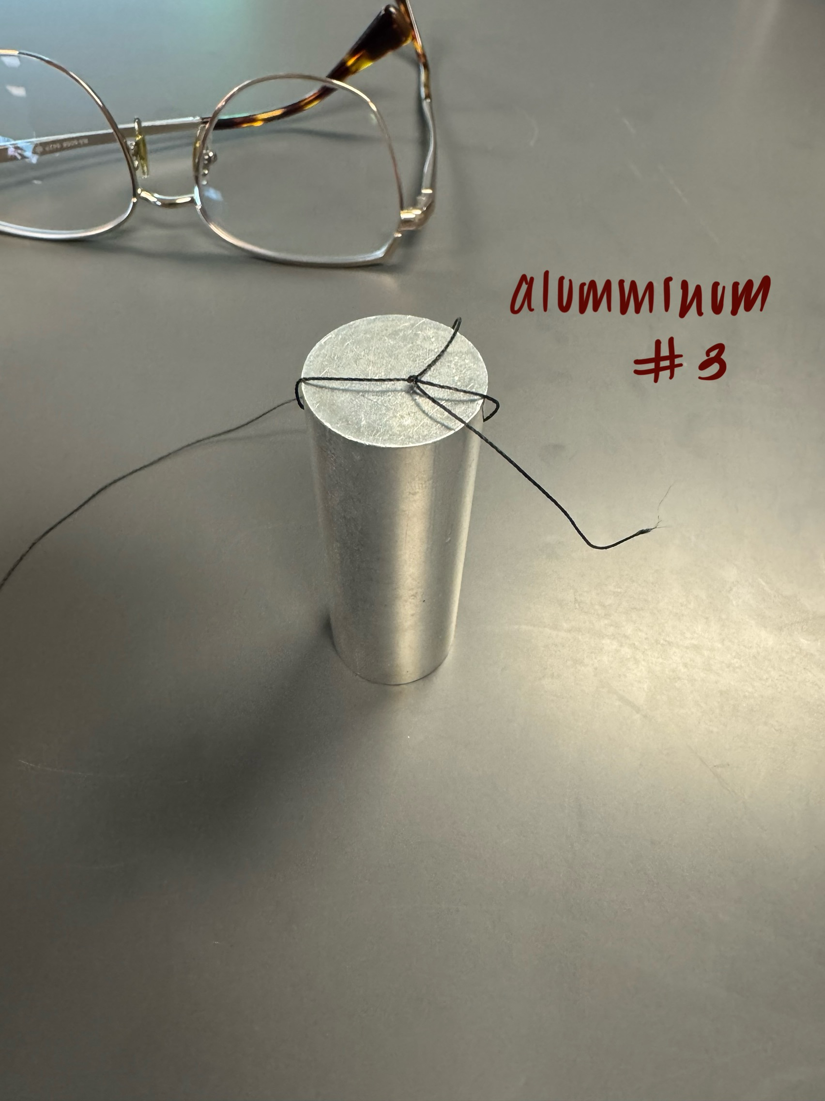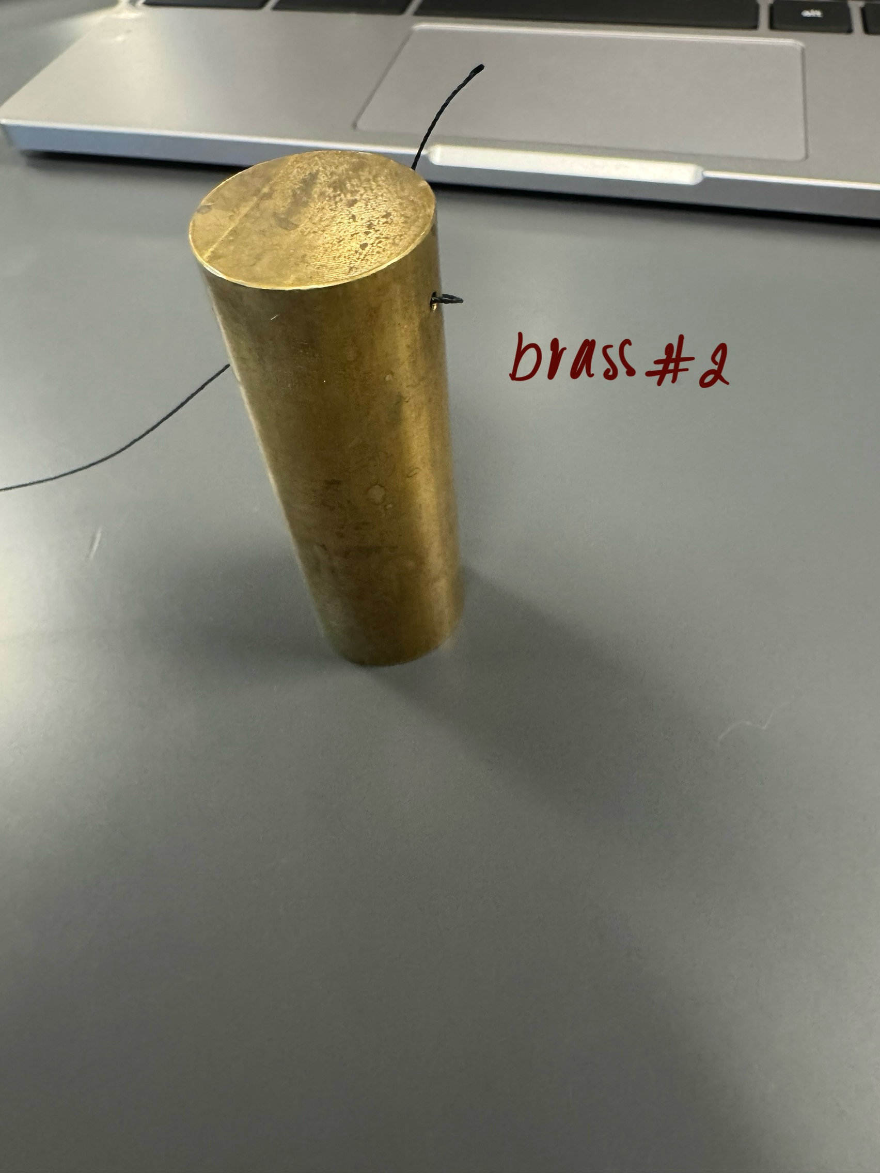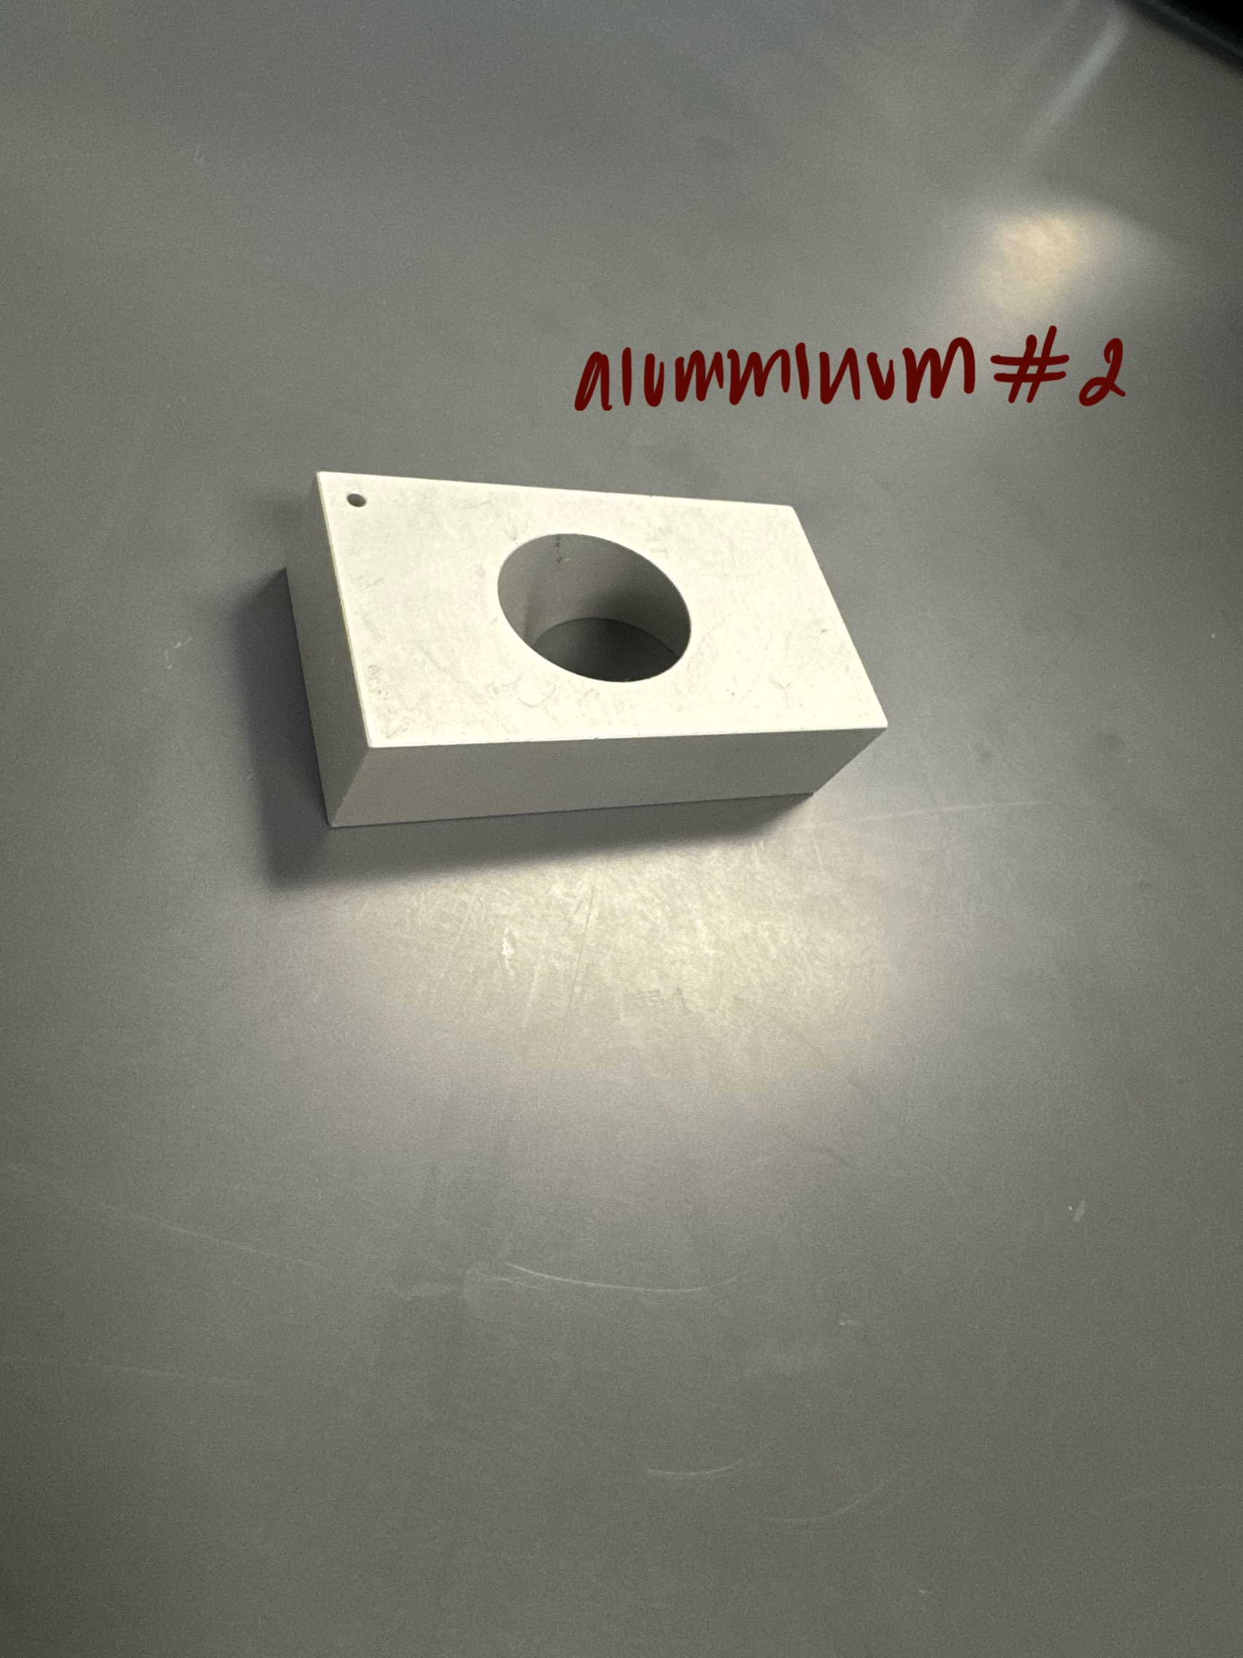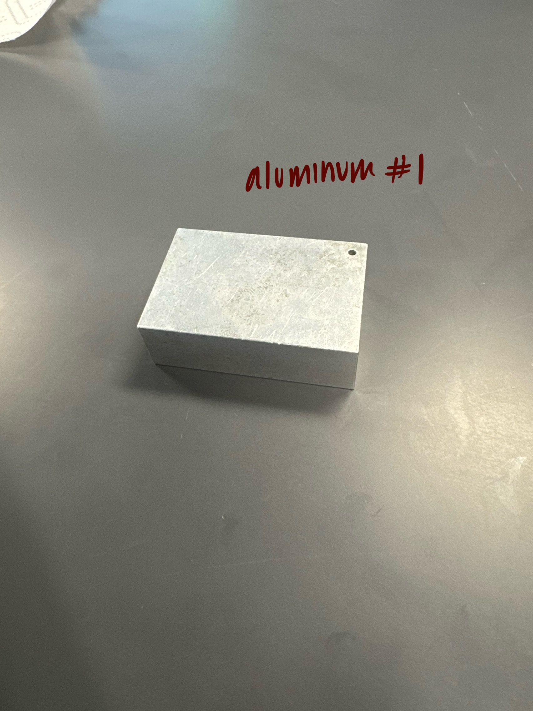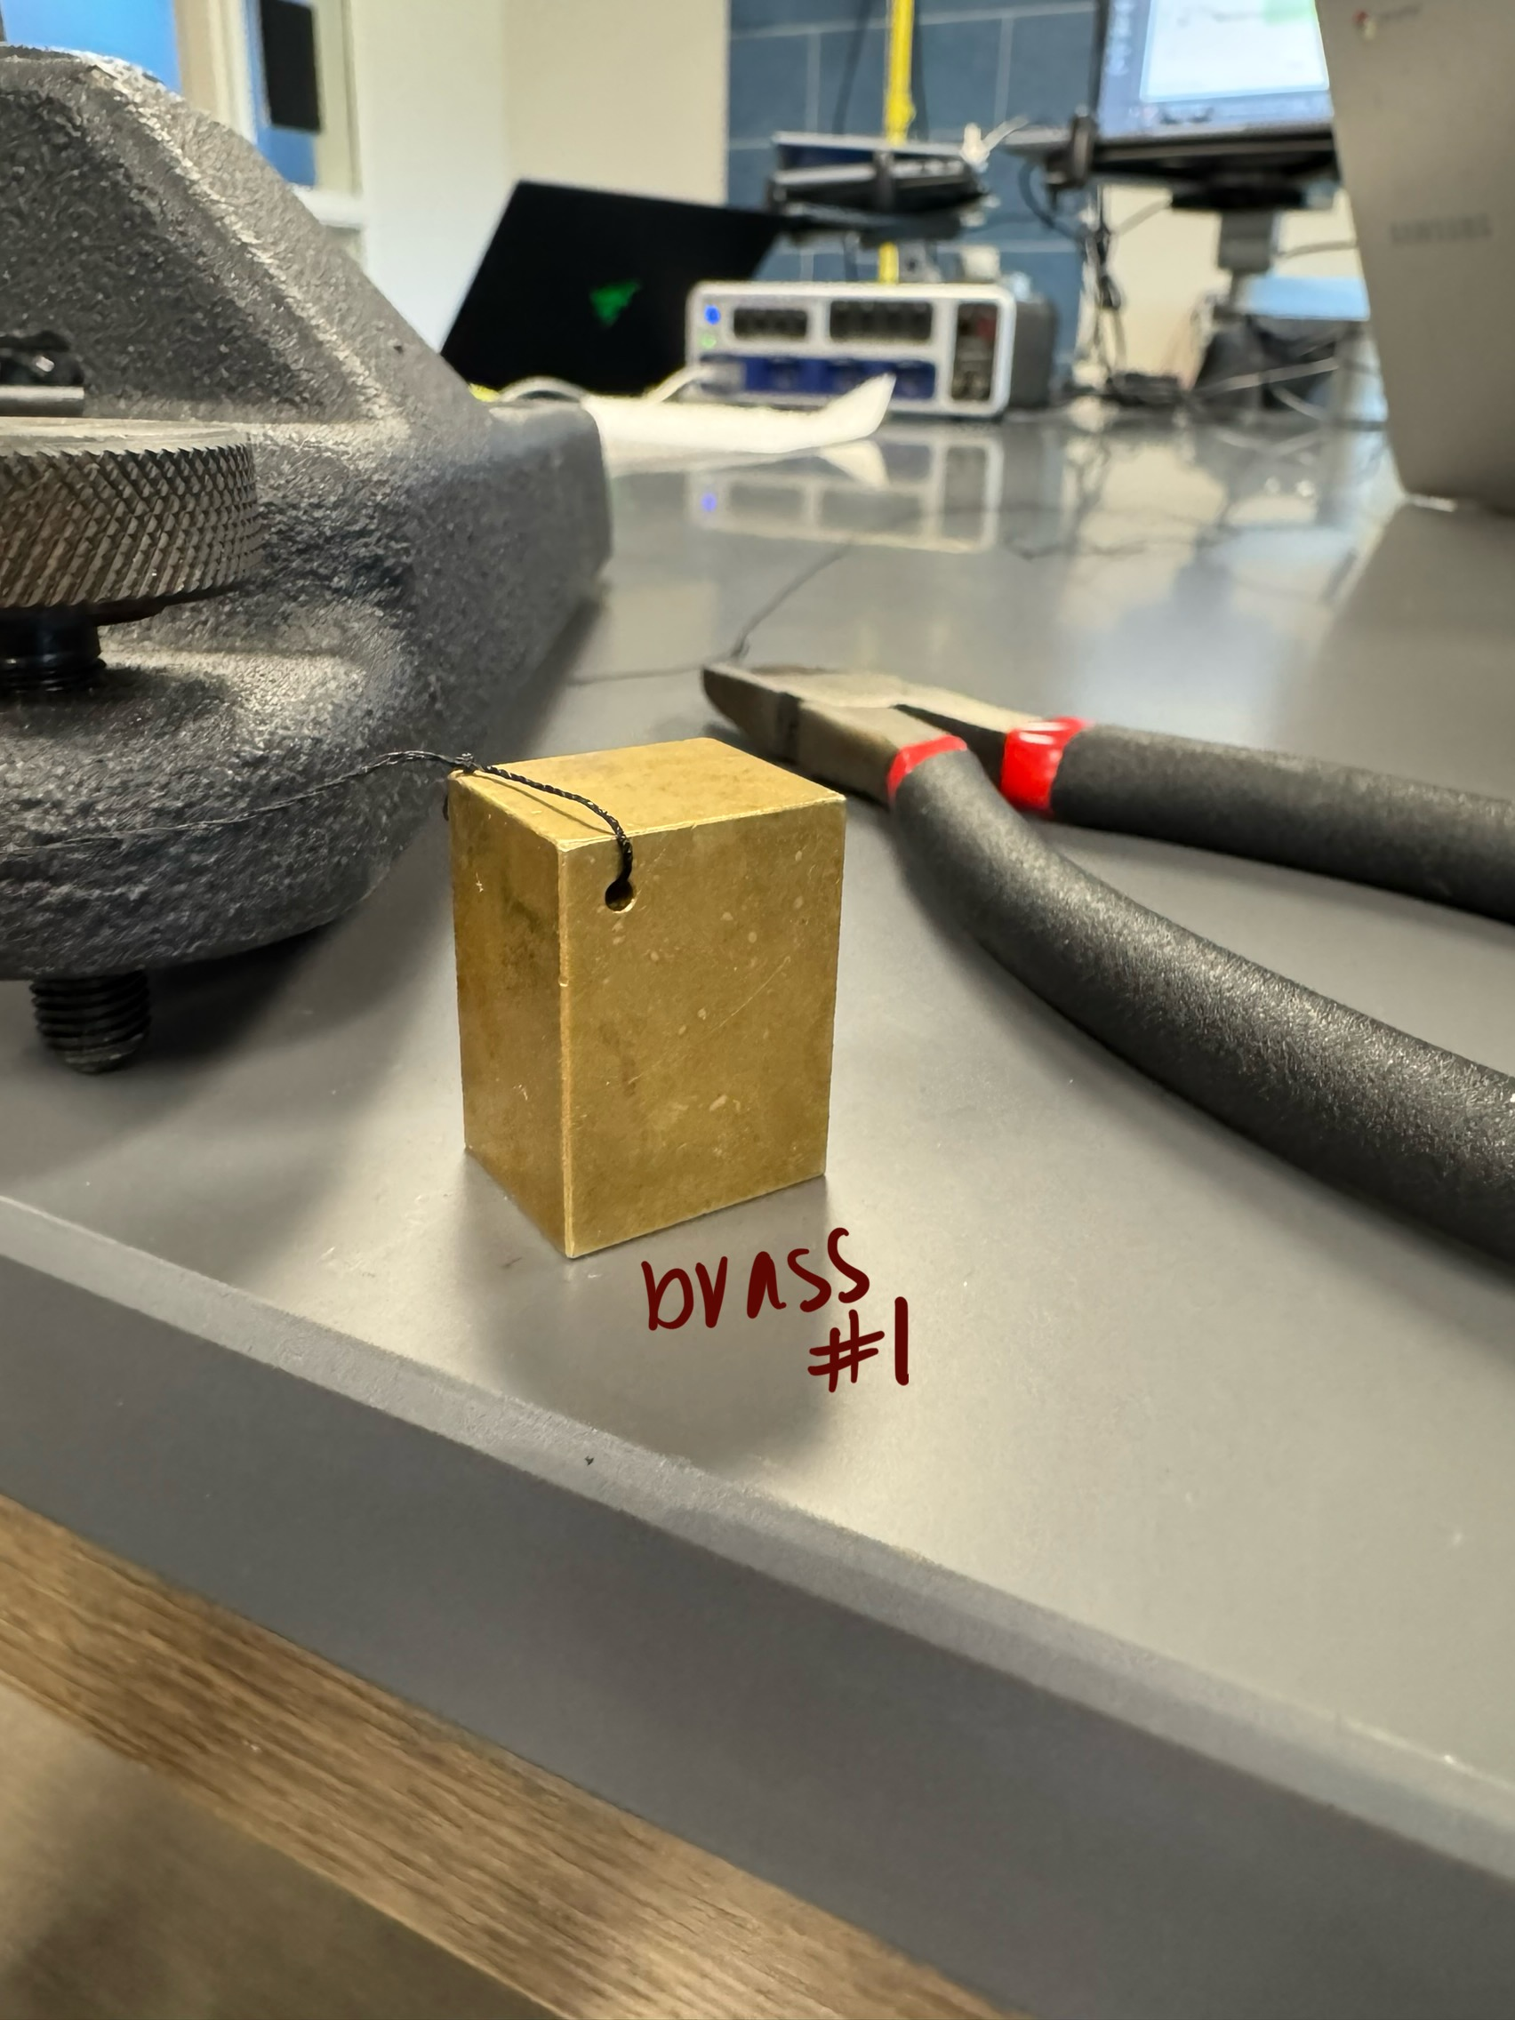

FORMULAS
Density: $ρ =\frac{M}{V}$
$B =ρ_{w}g V$
True weight in the air: $W_{A} =W_{A} g$
Weight of water: $W_{W} = M_{A}g - B$
Density of plastic in water $ρ_{P} = ρ_{w} [W_{A} / (W_{AW} - W_{WW})]$
$ρ_{P} = ρ_{w} [M_{A} / (M_{AW} - M_{WW})]$
Percent Error: $\% error = \frac{\left|Accepted value - Computed value\right|}{Accepted value }x100(\%)$

PROCEDURE:
USING FORCE SENSOR:
1. On the A-Base, fix the 45 cm Steel rod so that it is vertical.
2. Attach the Multi Clamp to the steel rod.
3. Attach the Super Pulley Rod to the Clamp, so that it is sticking out horizontally.
4. Attach the Force Sensor to the Super Pulley Rod, such that the hook of the force sensor is pointing vertically downwards.
5. Connect the Force Sensor to Science Workshop 850. Depending on the equipment available, the force sensor may be held in other ways
USING TRIPLE BEAM BALANCE:
Place the Triple Beam Balance at the edge of the table. Attach a thread under the pan of the Balance.
Part A: Solids that sink in water (objects 1-5):
1. Tie a piece of string onto each of the masses found in the Density Set. Tie a loop on the other end of the string so that it can be hooked onto the sensor.
2. Put enough water in a container so that the objects can fully submerge in it, but don't submerge the samples yet!
USING FORCE SENSOR
1. Turn on Capstone, and select Force Sensor in Hardware Setup.
2. Attach the first metal object to the hook of the Force Sensor. Hold the attached weight, make sure it’s not pulling on the hook. Now take the force sensor. Start recording with the weight in hand. The graph should show a smooth horizontal line at 0 N. If it is not 0 N, note the value as the zero error of the force sensor.
3. Lower the object slowly and release it. When the data stabilizes, it should be a horizontal line at its weight in air, WA.
4. Put the container with water under the hanging object, and then raise it such that the metal object is fully submerged in the water, but it should not be touching any side or base of the container.
Alternatively, the water container can be placed under the hanging object, and then lower the Force Sensor by loosening the nut on the Multi clamp, and lowering clamp plus Force Sensor along the steel rod until the object is dipped in water. Measure the apparent weight in water WW. Use equation 3 to get the density.
5. Repeat steps 9 to 11 for the other metal objects in the density set. Note: With Force Sensor, to get the weights, press “Record”, and wait a few seconds. There should be a constant value of force over time. Then highlight the data and find the “Mean Value”.
USING TRIPLE BEAM BALANCE:
Attach a string under the Triple Beam Balance, and get the masses of the objects when they are hanging under the balance in air, and when they are dipped in water, just like with the force sensor. In equation 3, the weights W can be replaced by the masses M. Compare the densities of these items with their accepted values, and get the percent errors.
Part B: Solid that floats on water (object 6):
USING FORCE SENSOR
1. The plastic cylinder has a density less than that of water.
2. Hang only the plastic cylinder under the hook, and get its weight in air, WA.
3. Attach a sinker to the bottom of the plastic cylinder and submerge only the sinker in the water, while the plastic cylinder is outside the water, but both are hanging under the balance. Read the apparent weight WAW (this is the weight of the plastic cylinder in air + sinker inside water).
4. Now lower the objects such that both the sinker and the plastic cylinder are in water. Read the apparent weight WWW. Take care that neither the plastic cylinder nor the sinker are touching the sides of the container. Use eqn. 4 to get the density of the Plastic Cylinder.
USING TRIPLE BEAM BALANCE:
Use the Triple Beam Balance in the same way as the force sensor. In equation 4, the weights W can be replaced by the masses M. Find the density by getting its volume by measuring its diameter and length, and calculating the density by eqn. 1. Calculate the percent difference between the two density values.

Part C: Solid that floats on water (object 6 or 7):
Measure the density of the wooden or plastic cylinder, without using any of the data acquired so far. The equipment has to include ONLY the wooden/plastic cylinder, a graduated cylinder, an overflow can (optional), water, and a pen or pencil (i.e. no balance, strings, sinker etc.). Devise a way to get the value of the density, and record the data and results in the report. Also, write in the report how the density was found.
DATA AND OBSERVATION:
Before setting up the device, between each step, the group would weigh the mass of all the different objects being tested. After the setup was complete, it was always checked that the sensor was zeroed to make sure the readings were as accurate as possible.
Once the experiment was ready to go, the cup of water was set on a metal plate that could increase or decrease the height of the water that was placed on the floor while the device stayed on the table. In contrast, when attaching the object to a string that was tied to the device, the object was slowly placed in the water while the metal plate was being raised. After a couple of trials, the group concluded that placing the water so far from the device on the table would cause more sources for percent error due to the string being so long. With the string being so long, this caused the reading to be unstable, and the object wouldn't stop swinging, which would impact the final results. Finally, once the placement of the water was on the table, this helped the readings become clearer and even.
Throughout the experiment, for each trial, the end goal was to find the density of different objects that were constantly being submerged in water. Once the objects alone were submerged in water and results were documented, the same object would be submerged again; however, it would be slowly put in the water with an added weight tied onto it.

CALCULATIONS:
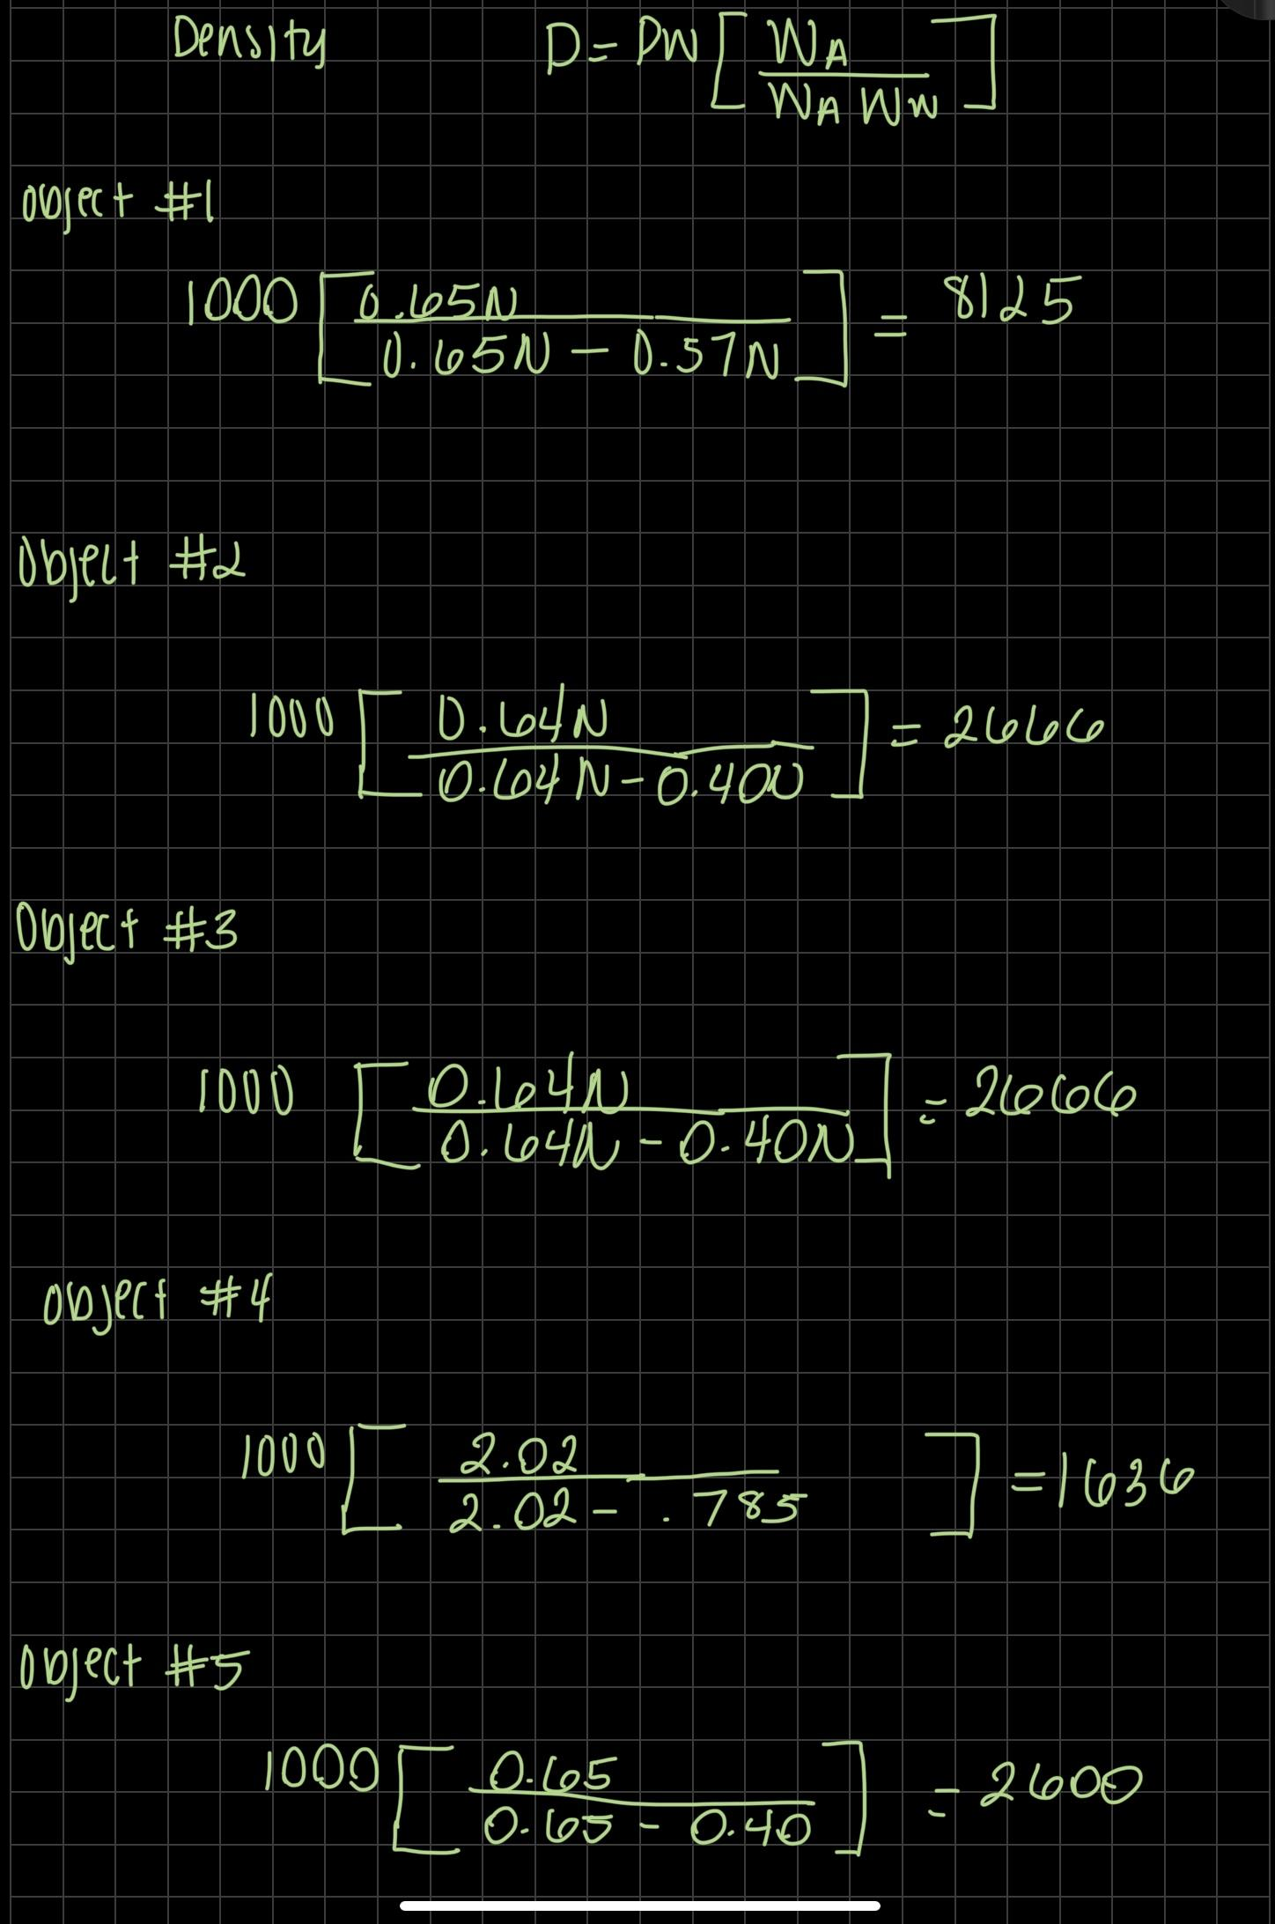
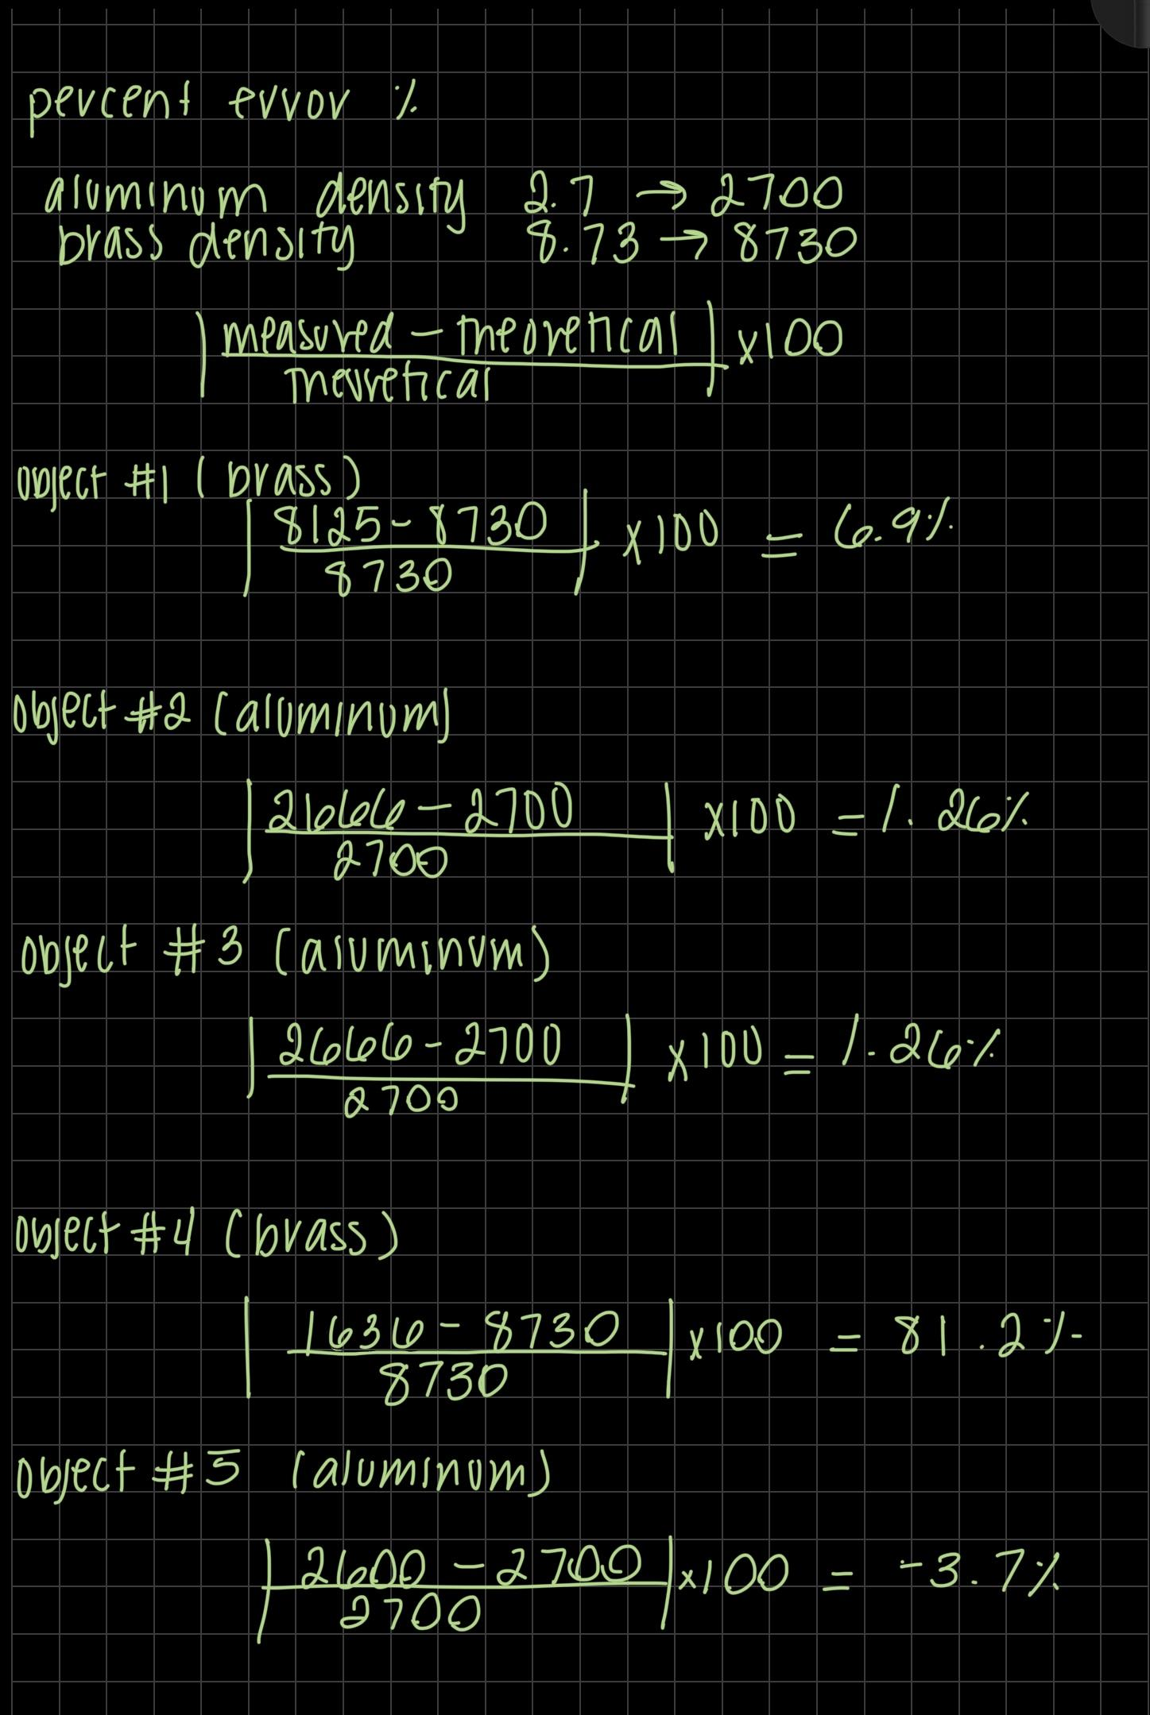11.
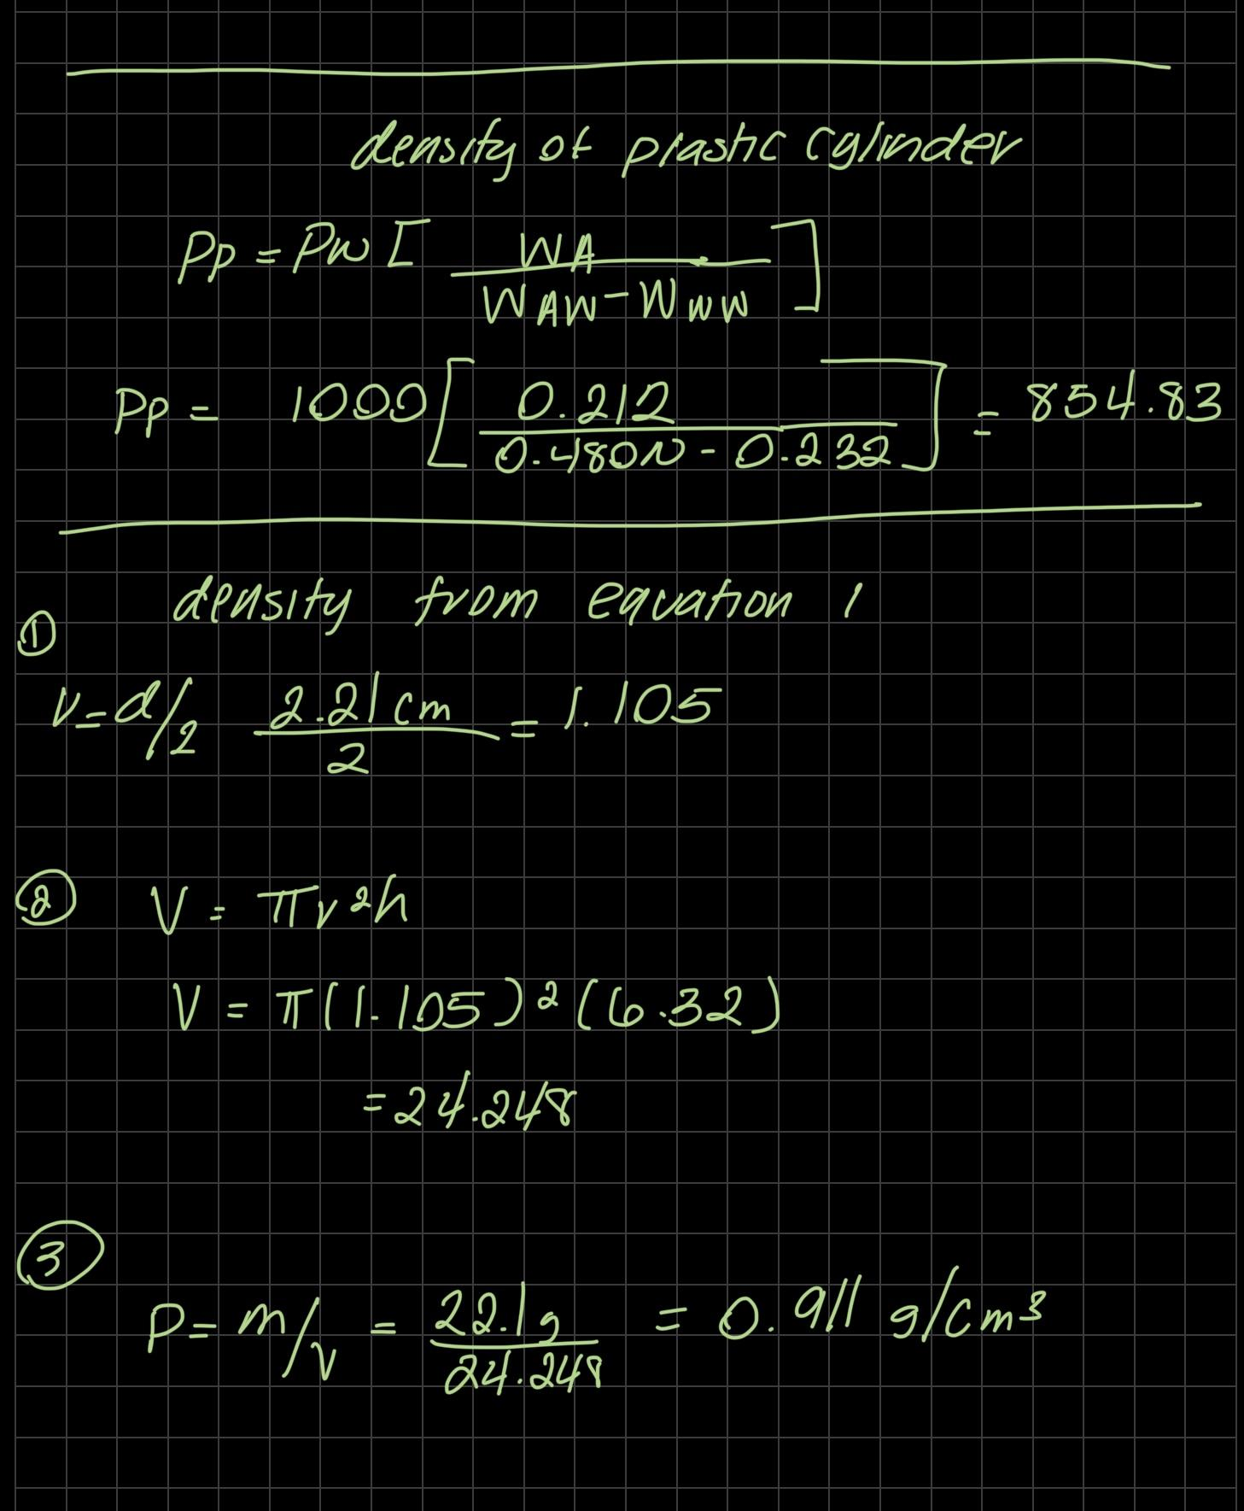

RESULTS
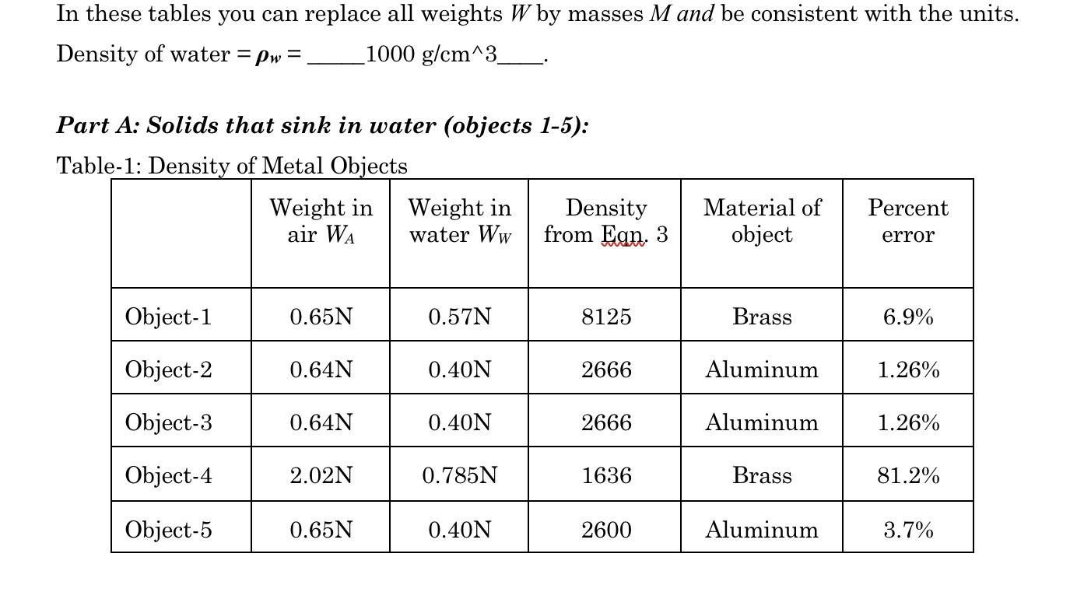
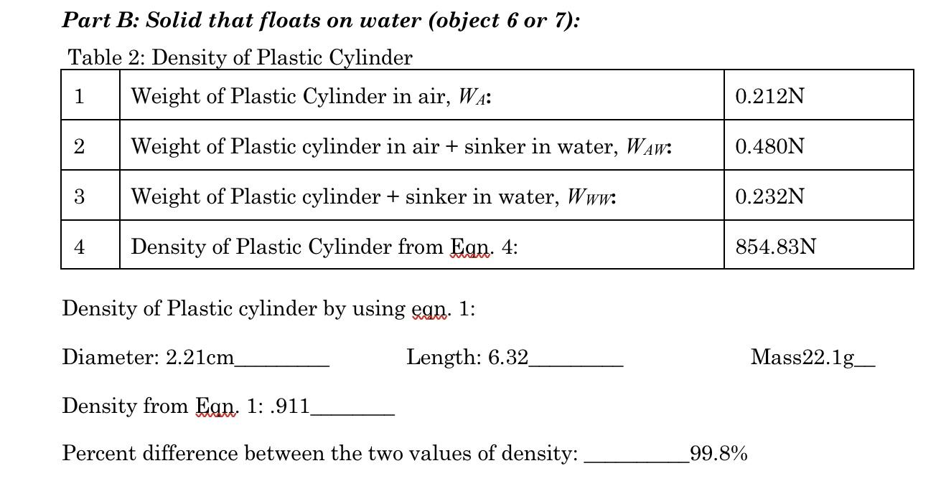

SOURCES OF ERROR:
- Imprecision in measurements. The measuring of the length, diameter, volume, and mass of the objects used in the experiment were all measured by eye and hand. This lack of precision can lead to errors when calculations are done.
- Miscommunication. Communicating large amounts of precise data without double checking the information being sent and received can lead to incorrect information being recorded.

DISCUSSION:
In this experiment, the densities of different solid items were measured and Archimedes' Principle was investigated using a force sensor. The force sensor was used to first determine the weight of things that sink in water. After that, their apparent weight was recorded after completely submerging them in water. The buoyant force, or the weight of the water displaced, was indicated by the difference in readings. The results that were gathered show that the densities of different objects were able to be measured and Archimedes’ Principle was able to be demonstrated by using a force sensor. The majority of the results were under a 10% percent error, except for the density of object 4, which had a 81.2% error. This was most likely caused by inaccuracies with gathering the measurements of object 4, such as the volume, mass, length, and diameter. When comparing the measured densities that were gathered to the theoretical densities of the objects, the measured densities were close to the theoretical densities except for object 4. The best way to improve the experiment is to try and be as accurate as possible with the measurements.
CONCLUSION:
The goal of this experiment was to measure the densities of different objects by using the Archimedes' Principle. The goal of the experiment was met by following the procedure and completing the lab. The results gathered were within a 10% percent error except for object 4, with the high percent error for object 4 most likely caused by inaccuracies in measurements. The hypothesis stated was supported by the data gathered. The key findings were the densities of various objects, which were measured by using a force sensor and submerging the objects in water.

